**Name: saline k.b**

**Roll No:33**

**Batch:mca -B**

**Date:31-3-2022**

**NETWORKING & SYSTEM ADMINISTRATION LAB**

**Experiment No.: 4**

**Aim**

Familiarization with linux commands.

**Procedure**

**1]cat –n b1.txt**

**Description:Put the line number to specify content.**

**Output Screenshot**

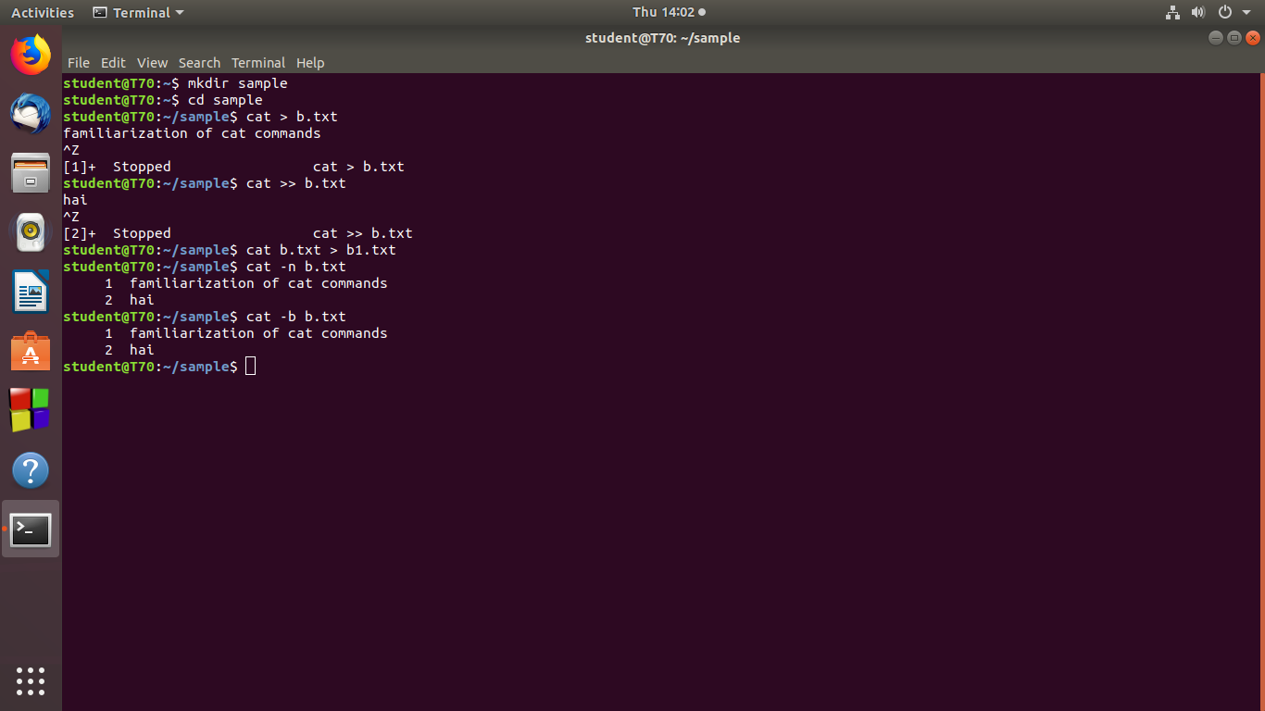

**2]cat –b b1.txt**

**Description:Remove empty files.**

**Output Screenshot**



**3]Touch**

**Touch b3.txt**

**Description:Is used create blank files.**

**Output Screenshot**

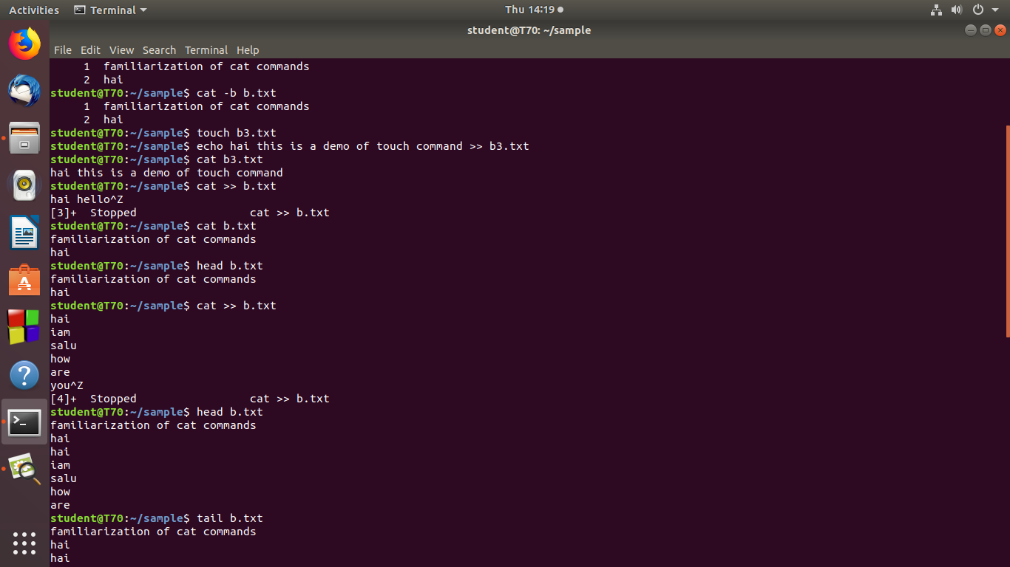

**4]echo[echo content >> b3.txt]**

**Description:Add the content to there blank file**

**Output Screenshot**



**5]Head**

**Description:Display first 10 lines(by default lines).**

**Head b1.txt**

**Head -4 b1.txt**

**Output Screenshot**



**6]Tail**

**Description:display tail portion(last 10 lines).**

**tail b1.txt**

**tail -3 b1.txt**

**Output Screenshot**

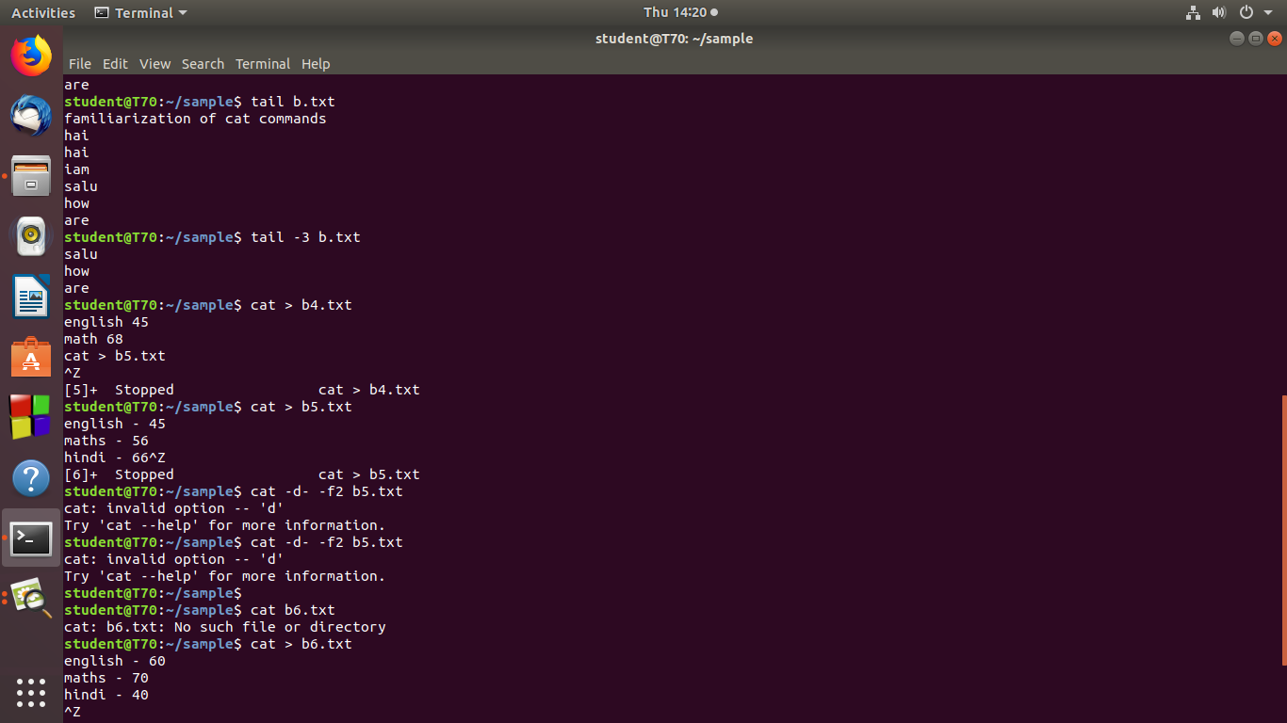

**7]commands used to cut the portion**

**Description:Divide the content**

**Cut –d ‘ ‘-f2 mark1**

**Output Screenshot**

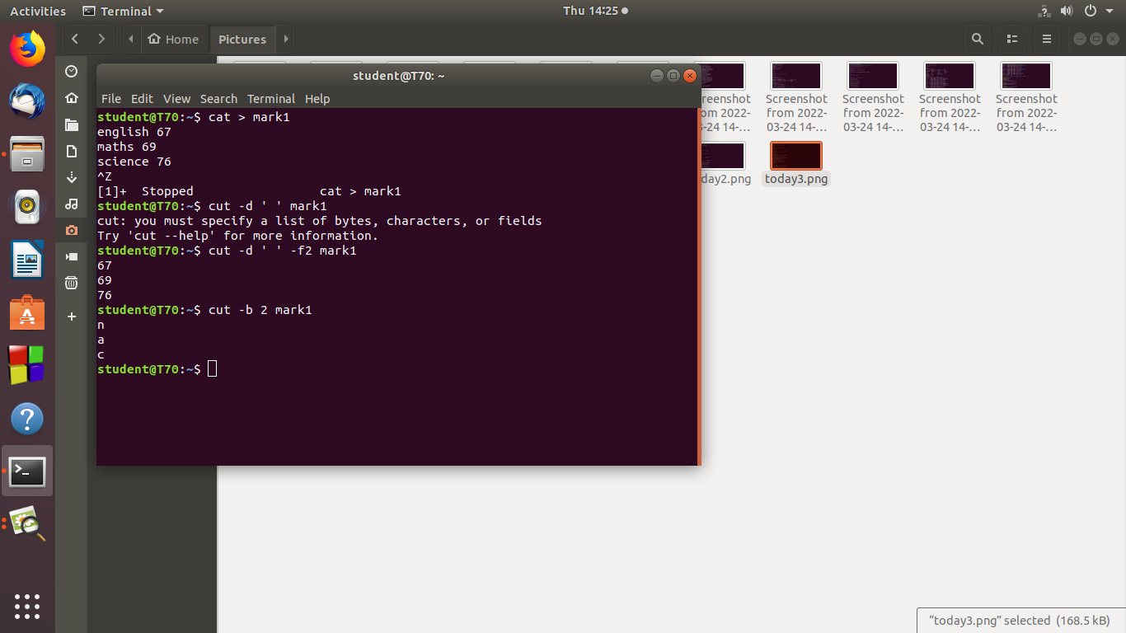

**8]cut –b 2 mark1**

**Description:byte by byte cutting.**

**Output Screenshot**



**9]cut – complement –c 1 mark1**

**Description:remove the first character complement cutting**

**Output Screenshot**

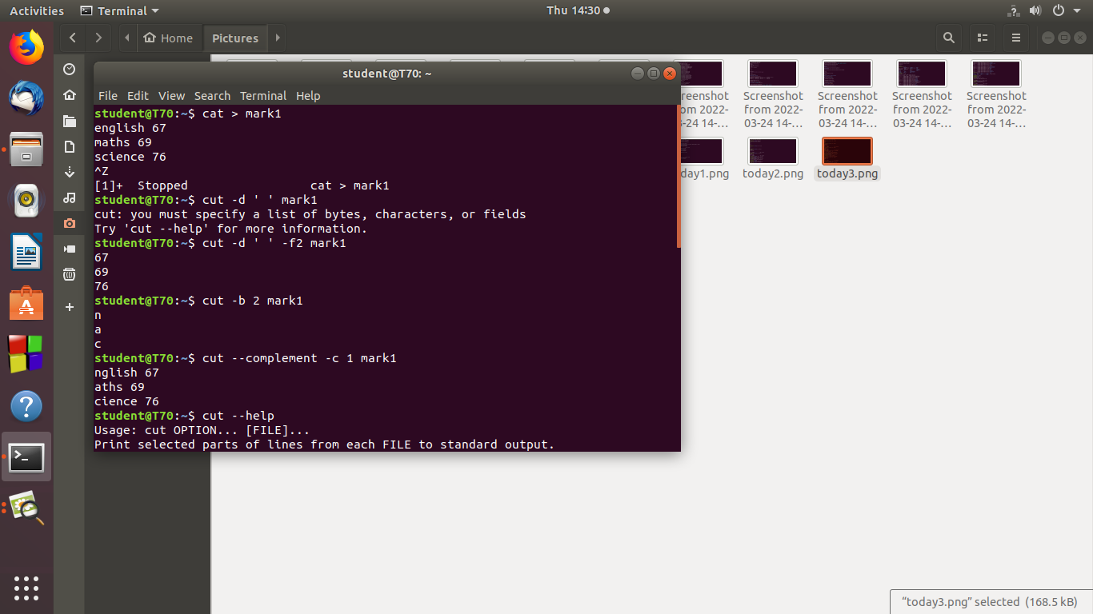

**10]paste commands**

**Cat > marvel1**

**Cat >marvel 2**

**Description :paste the content of one file to other.**

**Paste marvel1 and marvel2**

**output**

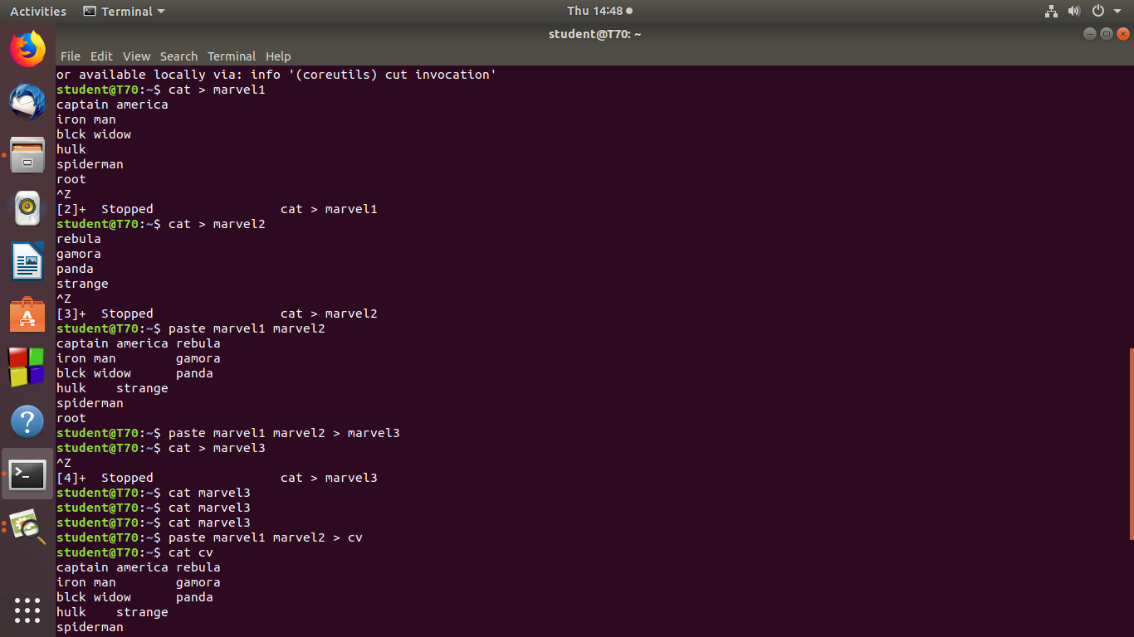

**11]paste marvel1 marvel2 >cv**

**Cat cv**

**Description:paste the content of marvel1 and marvel2 to a new file**

**Output Screenshot**



**12]paste –d ‘-‘**

**Description:pasting using delimiter.**

**Output Screenshot**

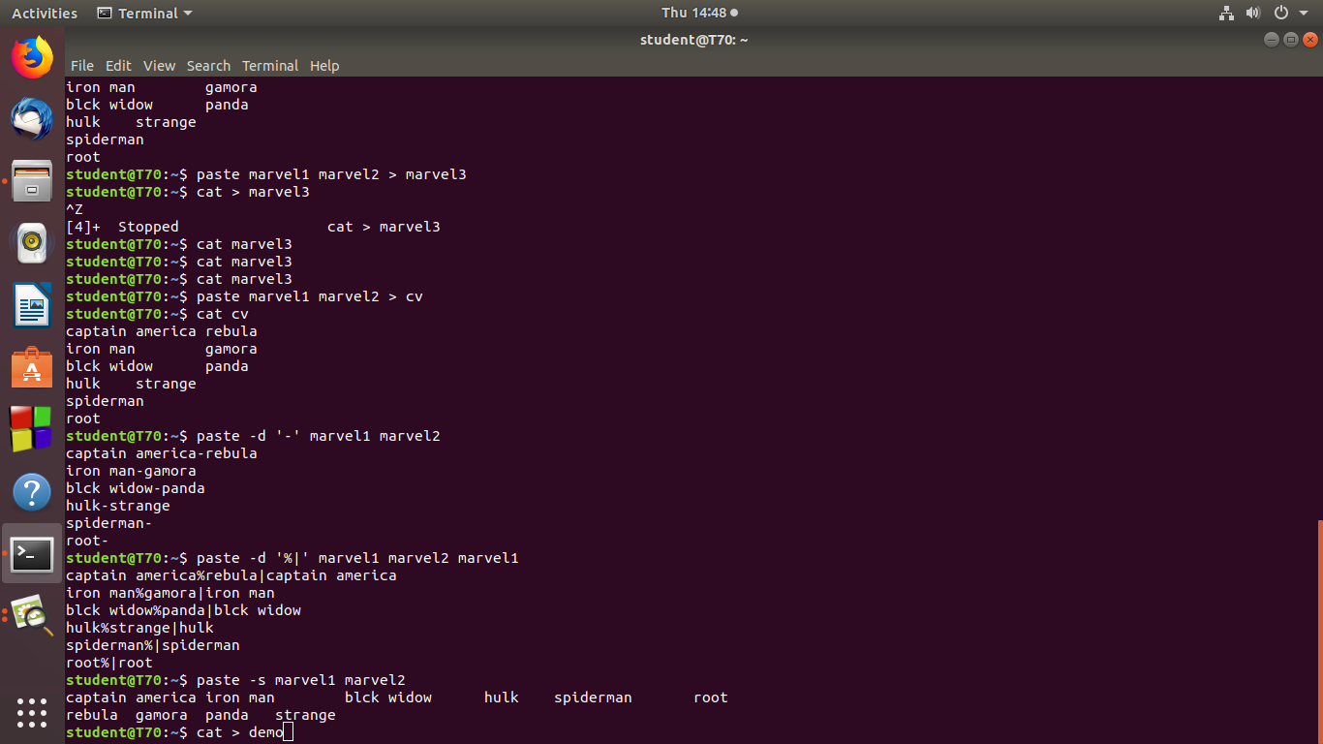

**13]paste –d ‘%’|’marvel1 marvel2 marvel1**

**Description:pasting using delimiter.**

**Output Screenshot**



**14]paste –s marvel1 marvel2**

**Description:paste the contents in series of line.**

**Output Screenshot**



**15]more commands.**

**Description:Add some more contents.**

**Output Screenshot**

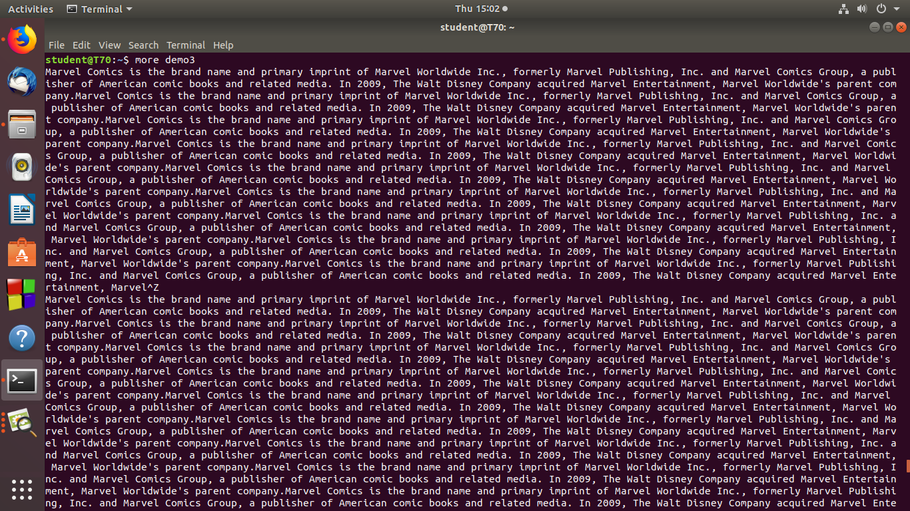

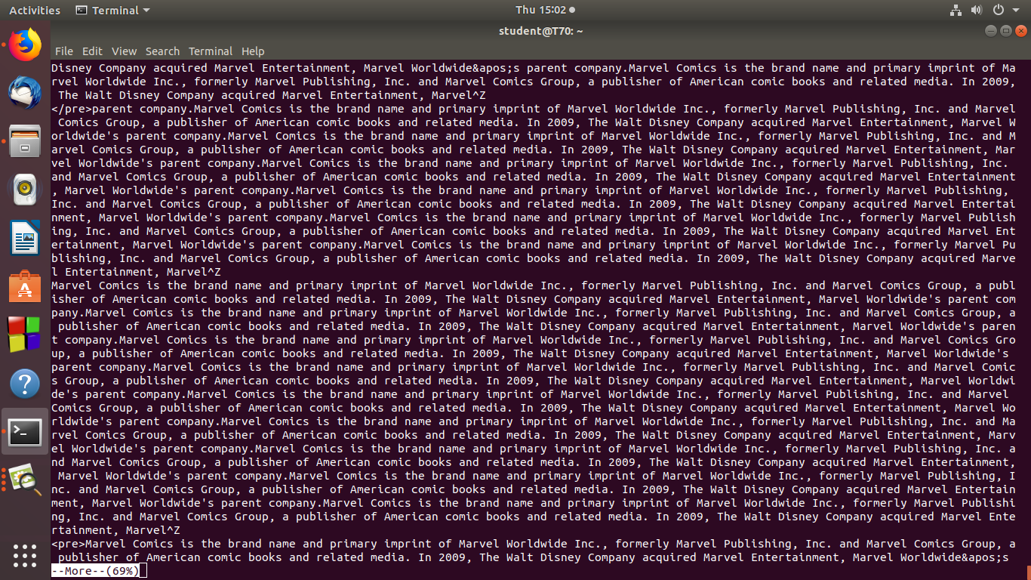

**16]more commands.**

**More +3 demo3**

**Description:Display more than 3 lines.**

**Output Screenshot**

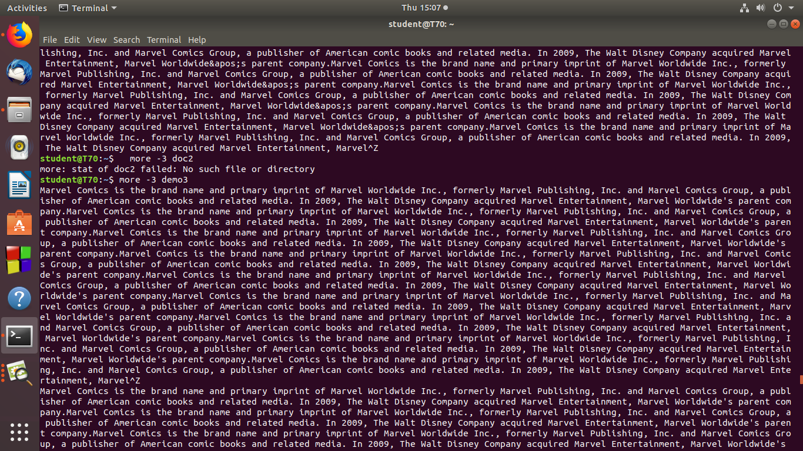

**17]more commands.**

**More –s demo3**

**Description:squeue the blank space.**

**Output Screenshot**

